PRACTICE QUESTIONS
- Solve the following dataset deploying Apriori and FP_Growth
Min_Supp=60&, Min_Confidence=80
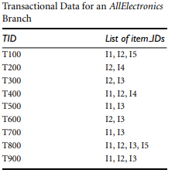

2) A database has five transactions. Let min sup = 60% and min conf = 80%
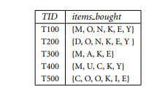
for FP-Growth drawing tree is important
(a) Find all frequent item-sets using Apriori and FP-growth, respectively. Compare the efficiency of the two mining processes.
(b) List all the strong association rules (with support s and confidence c) matching the following metarule, where X is a variable representing customers, and item i denotes variables representing items (e.g., “A,” “B,”): ∀x ∈ transaction, buys (X, item1) ∧ buys (X, item2) ⇒ buys (X, item3) [s,c]
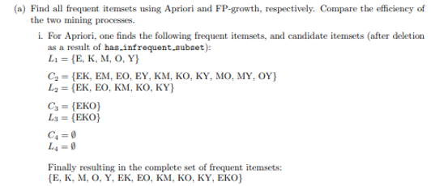

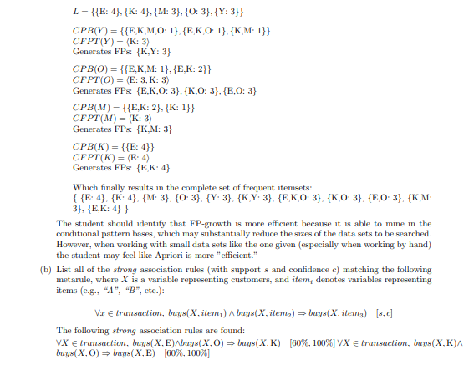
3) A database has four transactions. Let min sup = 60% and min conf = 80%.
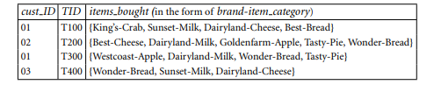
(a) At the granularity of item category (e.g., itemi could be “Milk”), for the rule template, ∀X ∈ transaction, buys (X, item1) ∧ buys (X, item2) ⇒ buys (X, item3) [s,c], list the frequent k-itemset for the largest k, and all the strong association rules (with their support s and confidence c) containing the frequent k-itemset for the largest k.
(b) At the granularity of brand-item category (e.g., itemi could be “Sunset-Milk”), for the rule template, ∀X ∈ customer, buys (X, item1) ∧ buys (X, item2) ⇒ buys (X, item3), list the frequent k-itemset for the largest k (but do not print any rules)
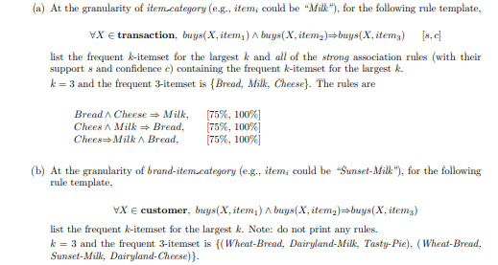

4.) Give a short example to show that items in a strong association rule may actually be negatively correlated.
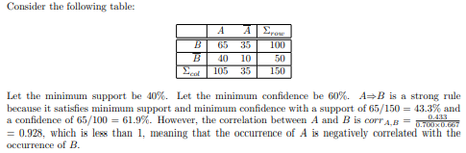
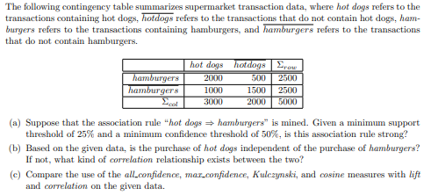
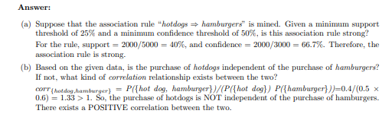
5.) Suppose you have the set C of all frequent closed itemset on a data set D, as well as the support count for each frequent closed itemset. Describe an algorithm to determine whether a given itemset X is frequent or not, and the support of X if it is frequent.
Answer:
Algorithm: Itemset Freq Tester. Determine if an itemset is frequent.
Input: C, set of all frequent closed itemsets along with their support counts; test itemset, X.
Output: Support of X if it is frequent, otherwise -1.
Method:
(1) s = ∅;
(2) for each itemset, l ∈ C
(3) if X ⊂ l and (length(l) < length(s) or s = ∅) then {
(4) s = l;
(5) }
(6) if s ̸= ∅ then {
(7) return support(s);
(8) }
(9) return -1;

6.) An itemset X is called a generator on a data set D if there does not exist a proper sub-itemset Y ⊂ X such that support(X) = support (Y). A generator X is a frequent generator if support(X) passes the minimum support threshold. Let G be the set of all frequent generators on a data set D. (a) Can you determine whether an itemset A is frequent and the support of A, if it is frequent, using only G and the support counts of all frequent generators? If yes, present your algorithm.
Otherwise, what other information is needed? Can you give an algorithm assuming the information needed is available?
(b) What is the relationship between closed itemsets and generators?
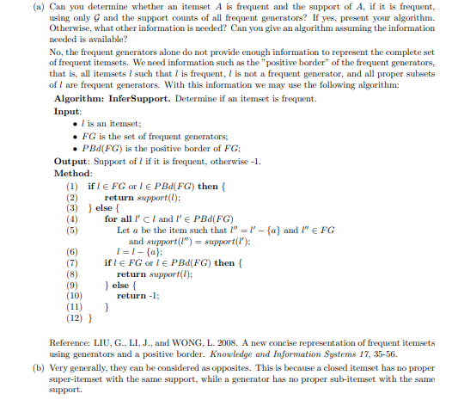
7.) The Apriori algorithm makes use of prior knowledge of subset support properties.
(a) Prove that all nonempty subsets of a frequent itemset must also be frequent.
(b) Prove that the support of any nonempty subset s ′ of itemset s must be at least as great as the support of s.
(c) Given frequent itemset l and subset s of l, prove that the confidence of the rule “s ′ ⇒ (l − s)” cannot be more than the confidence of “s ⇒ (l − s)”, where s ′ is a subset of s.
(d) A partitioning variation of Apriori subdivides the transactions of a database D into n nonoverlapping partitions. Prove that any itemset that is frequent in D must be frequent in at least one partition of D.
Answer:
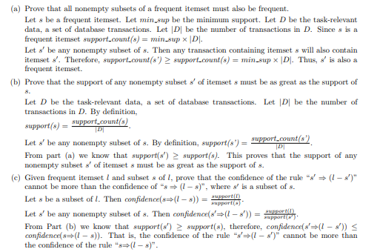
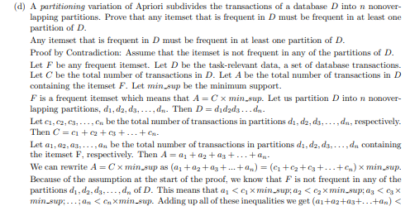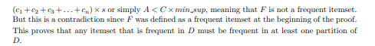

8) For each of the following questions, provide an example of an association rule from the market basket domain that satisfies the following conditions. Also, describe whether such rules are subjectively interesting.
(a) A rule that has high support and high confidence.
Answer: Milk −→ Bread. Such obvious rule tends to be uninteresting.
(b) A rule that has reasonably high support but low confidence.
Answer: Milk −→ Tuna. While the sale of tuna and milk may be higher than the support threshold, not all transactions that contain milk also contain tuna. Such low-confidence rule tends to be uninteresting.
(c) A rule that has low support and low confidence.
Answer: Cooking oil −→ Laundry detergent. Such low confidence rule tends to be uninteresting.
(d) A rule that has low support and high confidence.
Answer: Vodka −→ Caviar. Such rule tends to be interesting

9.) Consider the data set shown in Table 6.1.
(a) Compute the support for itemsets {e}, {b, d}, and {b, d, e} by treating each transaction ID as a market basket.
Answer:
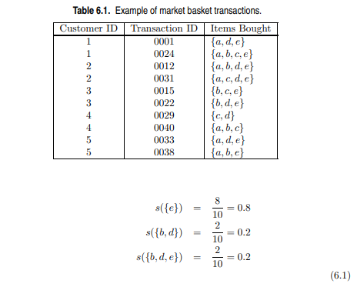
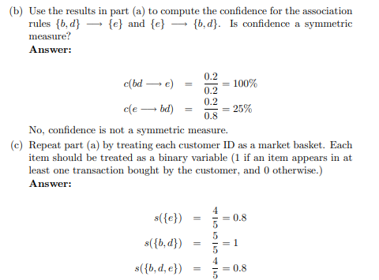
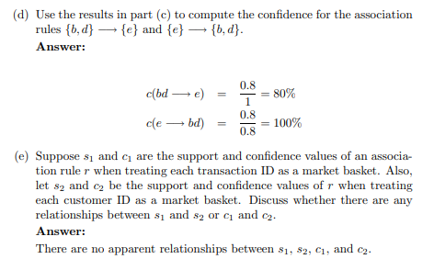
10. (a) What is the confidence for the rules ∅ −→ A and A −→ ∅?
Answer: c(∅ −→ A) = s(∅ −→ A).
c(A −→ ∅) = 100%.
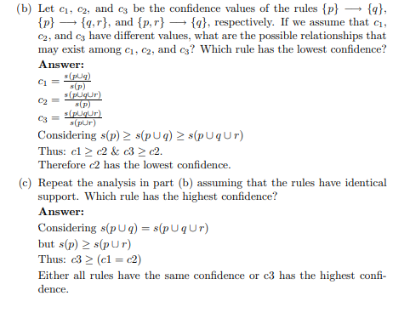
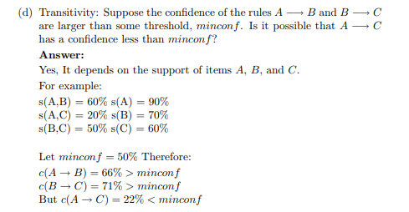
11) Solve the following applying With candidate generation and without candidate generation techniques with Min_supp as 30% and Min_Conf as 70%
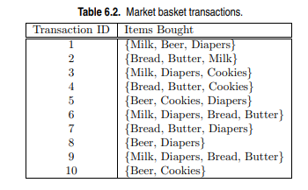
12) Solve the following applying With candidate generation and without candidate generation techniques with Min_supp as 40% and Min_Conf as 80%
